Layaan Isaacs
[Company name] [Company address]
Website Proposal 2

Contents
Index 2
Website Project Proposal 2 3
1. Organisation Overview 3
Mission Statement 4
Vision Statement 4
Target Audience 4
2. Website Goals and Objectives 5
Objectives include: 5
Key Performance Indicators (KPIs) 5
3. Current Website Analysis 6
Strengths 6
Weaknesses 6
Areas for Improvement 6
4. Proposed Website Features and Functionality 7
5. Design and User Experience 8
Colour Scheme 8
Typography 8
Layout and Design 8
User Experience Considerations 8
6. Technical Requirements 9
7. Timeline and Milestones 9
8. Budget 9
References 10

Index
Section | Page Number
Cover Page | 1
Table of Contents | 2
1. Introduction | 3
2. Purpose of the Website | 4
3. Target Audience | 5
4. Description of Web Pages | 6
4.1 Home Page | 6
4.2 Cake Gallery | 7
4.3 Custom Orders Page | 8
4.4 Pricing Page | 9
4.5 Contact Page | 10
5. Budget for Each Web Page | 11
6. Conclusion | 12
7. References

Gallery

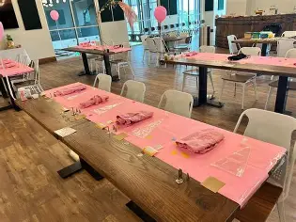

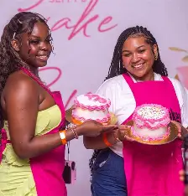

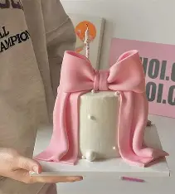

Flowchart

Website Project Proposal 2
Target Organisation: Yaana’s Cakes (Cake Decorating Business)

1. Organisation Overview
Name: Yaana’s Cakes
Yaana’s Cakes is a small cake decorating business that specialises in creating custom cakes for birthdays, weddings, and special events. The business focuses on creative cake designs and high-quality ingredients to produce cakes that are both visually appealing and delicious.
The business was started to provide personalised cakes that match customers’ specific themes and celebrations. Each cake is designed carefully to meet the client’s request, making every order unique.
Currently, Yaana’s Cakes promotes its work through social media by sharing pictures of decorated cakes and customer orders. However, the business plans to expand by creating a website where customers can view cake designs, learn about available services, and contact the business to place orders.

Mission Statement
The mission of Yaana’s Cakes is to create beautifully designed cakes that make special occasions even more memorable.

Vision Statement
The vision of Yaana’s Cakes is to become a well-known cake decorating business that is trusted for creative designs and quality products.

Target Audience
The target audience includes:
- Individuals planning birthdays and celebrations
- Wedding clients looking for custom cakes
- Parents organising parties for children
- Customers looking for personalised cake designs

2. Website Goals and Objectives
The main goal of the Yaana’s Cakes website is to showcase cake designs and make it easier for customers to request orders.

Objectives include:
- Displaying cake designs and previous work
- Providing information about custom cake services
- Allowing customers to enquire about orders
- Promoting the business and attracting new customers

Key Performance Indicators (KPIs)
Success of the website will be measured through the number of visitors and customer enquiries.
Website analytics tools such as Google Analytics will be used to track visitor activity and page views.

3. Current Website Analysis
Currently, Yaana’s Cakes does not have a dedicated website and mainly uses social media platforms to promote its cakes.

Strengths
- Creative cake designs
- Strong visual content
- Growing social media presence

Weaknesses
- No central platform for displaying all cake designs
- Customers cannot easily find business information
- Ordering process is not structured

Areas for Improvement
Creating a website will provide:
- A professional platform for the business
- A gallery of cake designs
- Easier communication with customers

4. Proposed Website Features and Functionality
The Yaana’s Cakes website will include the following pages:
Homepage (index.html)
A welcoming page showing featured cake designs and an introduction to the business.
About Page (about.html)
Information about the business and the story behind Yaana’s Cakes.
Cake Gallery (gallery.html)
A gallery displaying different cake designs and previous orders.
Services Page (services.html)
Information about cake types, custom orders, and pricing guidelines.
Contact Page (contact.html)
Contact details and an enquiry form where customers can request cake orders.

5. Design and User Experience

Colour Scheme
The website will use soft and friendly colours such as:
- Pastel pink
- Cream
- Light brown
These colours reflect sweetness and creativity.

Typography
Headings will use decorative fonts to match the theme of cake decorating, while body text will use readable fonts such as Arial.

Layout and Design
The layout will be colourful and image-focused to highlight cake designs.

User Experience Considerations
- Simple navigation between pages
- Clear gallery sections
- Mobile-friendly design
- Fast loading images
Low-fidelity wireframes will be created before development.

6. Technical Requirements
The website will be developed using HTML.
The project will require a domain name such as yaanascakes.co.za and web hosting services.

7. Timeline and Milestones
Week 1 – Proposal and planning
Week 2 – Content research and image collection
Week 3 – Sitemap and website planning
Week 4 – HTML development
Week 5 – Testing and final improvements

8. Budget
Domain registration: R250 per year
Web hosting: R1200 per year
Website development: R5000 once off
Maintenance: R2000 per year
Estimated total: R8350

References
- BBC Good Food (2025) Cake decorating ideas. Available at: https://www.bbcgoodfood.com/howto/guide/cake-decorating (Accessed: 11 March 2026).
- Wilton (2025) Cake decorating techniques and tips. Available at: https://www.wilton.com/cake-decorating/ (Accessed: 11 March 2026).
- Food Network (2025) Cake decorating ideas and techniques. Available at: https://www.foodnetwork.com/how-to/packages/food-network-essentials/cake-decorating (Accessed: 11 March 2026).

